<div id="date">2015-10-22</div>

This is for date, not for tag, please change it back. Since you change this, all my post’s date wrong.

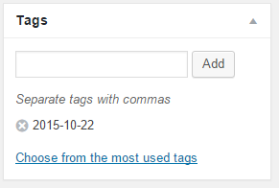

Why the date will add to tags? Please remove it.

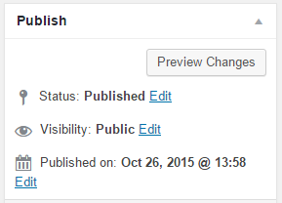

<div id="date">2015-10-22</div> is for published on date. (Default), I guess you edited something on the plugin. Can you change it back? We just want you do the category part.